Parallel filtering of three dimensional image sequences

Karol Mikula

Department of Mathematics, Slovak University of Technology,
Radlinskeho 11, 813 68 Bratislava, Slovakia

Abstract. A parallel implementation of the recent nonlinear multiscale analysis model ([SMS]) for filtering of space-time image sequences has been developed and applied to 3D biomedical images. The model which we use for the space-time filtering is based on a partial differential equations (PDEs) approach, namely PDEs of degenerate diffusion type are applied to the initially given image sequence. Since the images are given on discrete grids, the nonlinear PDE is discretized by a semi-implicit finite volume method in order to get fast and stable solution which is also convenient to parallelization.

An input image sequence, representing an acquizition of moving objects, can be modelled by a real function u⁰(x, ), u⁰:  [0,T], where   ^{N} represents a spatial domain, x=(x₁,…,x_{N}) represents a spatial point and  a point in a time interval [0,T] in which the acquizition is realized. In practice,  is a rectangular domain, N=2 or 3 and, in special applications, the time sequence can be periodically prolonged from [0,T] to . A typical example which can be represented by such u⁰ is an ultrasound acquizition of a beating heart in 3D echocardiography. The application of PDE to the initially given (noisy) image sequence can be understood as its embedding to the so-called nonlinear scale space. The axioms and fundamental properties of such embedding have been given and studied in [AGLM] and the notion of image multiscale analysis has been introduced. The image multiscale analysis associates with u⁰ a family u(t,x,) of smoothed - simplified images (in our case a family of smoothed sequences) depending on an abstract parameter t, the scale. As it has been proved in [AGLM], if such family fulfills basic assumptions - pyramidal structure, regularity and local comparison principle - then u(t,x, ), u:[0,T_{s}]  [0,T] can be represented as the unique viscosity solution of a general second order degenerate parabolic partial differential equation. The equations of degenerate parabolic type has a smoothing property, so they are natural tool for filtering (image simplification) by removing spurious structures, e.g. a noise. However, the simplification should be "image oriented", e.g. it should respect edges and do not blur them. Or, it should recognize motion of a structure in the image sequence and consequently the smoothing-diffusion should respect the motion coherence in subsequent frames. Such or even more sofisticated requirements, related to geometrical characteristics of the image, bring strong nonlinearity (diffusion can depend on the absolute value of the spatial gradient of the intesity function | u| as on the edge indicator) or even degeneracy (diffusion can be stopped in points which are “un-noisy” by motion field information) into the parabolic PDE. The main question is how to choose a diffusion mechanism with the aim to extract relevant information from the sequence, filter out the noise and enhance moving structures. To that goal we would like to use an additional information (in comparison with static image processing) given by motion coherence in the image sequence. We assume that certain objects acquired in a different time, and thus being in different frames of the sequence, are formed by points that preserve their intensity along the motion trajectory. Such objects are called Lambertian structures. Moreover we assume that motion is Galilean locally in time, i.e. the motion trajectories are smooth. Designing the model equations we will consider the following quantity (proposed by Guichard)

clt(u) = min_{w1,w2} (|<u, w1-w2>|+|u(t,x-w1,-)-u(t,x,)| +|u(t,x+w2,+)-u(t,x,)|) /( )² (1)

where w1, w2 are arbitrary vectors in ^{N} and  is the real time increment. The scalar function clt(u) introduces a measure of coherence in time for the moving structures. It consists of the sum of three positive parts and we want to find the minimum in all possible directions w1, w2. The last two terms in the brackets are related to the differences in intensities of end-points of the candidate Lambertian velocity vectors w1, w2. To find directions of such vectors we look at points which have the closest intensity value to the intensity u(t,x,) in the previous frame and in the next frame. If we find corresponding Lambertian points both terms vanish. The first term |<u,w1-w2>| corresponds to the so called apparent acceleration, i.e. to the difference between candidate Lambertian velocity vectors w1 and w2 in the direction of u. The value of clt(u) vanishes for the Lambertian points that are in Galilean motion. On the other hand for the noisy points there is no motion coherence and thus clt(u) will be large there. Concerning the space coherence, we assume that distinguished structures are located in the regions with a certain mean value of the image intensity function and that object boundary forms an edge in the image. In order to construct spatial diffusion process we will require specific behavior on the edges, e.g. it is desirable to not blur them, to keep their position as fixed as possible. Another reasonable choice can be related to a smoothing of the edges by intrinsic diffusion (for that goal, flow by mean curvature can be used). There exist diffusion processes designed to respect such features, we can choose e.g Perona-Malik like anisotropic diffusion, mean curvature flow of curves and surfaces in the level set fomulation, models based on minimization of image total variation etc. To combine time coherence of moving objects with their spatial localization for parallel implementation we consider the following equation
u_{t} = clt(u) sd(u) (2)
where the spatial diffusion term sd(u) is given either by the Perona-Malik-like term, i.e.
sd(u)= .( g(| G  u|) u) (3)
where g(s) = 1/(1+K s^2), K is a constant and G represents a smoothing kernel, or, we consider a level- set-like term for the spatial smoothing, i.e.
sd(u)=|u| . (u / |u |). (4)
The equation (2) preserves moving in time structures as well as keeps their spatial edges (in the case (3)), or, it makes smooth the moving object silhouette by the intrinsic diffusion (in the case (4)). In both cases, we consider zero Neumann boundary conditions in the spatial part of the boundary and e.g. periodic boundary conditions in the time boundary of the sequence.

We discretize the partial differential equation (2) by the ideas of the finite volume method in space and using a semi-implicit finite differencing in the scale ([MR]). The nonlocal term clt(u) is also taken explicitly, from the previous scale step, and it is computed by means of discrete version of (1). Such approach leads to solving of linear system of equations in order to process every frame of the sequence in every discrete scale step (for details see [SMS]). In order to parallelize the algorithm we have used shared memory parallel computer ORIGIN 2000 at CINECA, InterUniversity Computing Center, Bologna. The computation of clt(u) can be split voxel by voxel and the system solving can be also done in parallel. The structure of the algorithm and the C-language implementation allow us to use Open MP C Application Program Interface. Table 1 presents computational times of processing of one 3D frame (2097152 voxels) of Real-Time 3D Echo data set (RT3DE Volumetrics). In order to estimate the term clt(u) we use 5³ voxels neighbourhood; then the problem is computationally very hard. Using parallel computer we can process a 3D frame of the sequence in about 30 seconds, in spite of about 30 minutes needed at usual PC (Pentium II 500 MHz). In Figure 1 we present 3D visualization of left ventricular surface before (left) and after (right) three scale steps of the algorithm. The visualization is taken from [SMSL] where the sequential image sequence processing has been applied to RT3DE Volumetric images.

Number of processors | Computing time in seconds
1 processor | 410 sec
2 processors | 210 sec
4 processors | 144 sec
8 processors | 84 sec
16 processors | 44 sec
32 processors | 32 sec
Table 1.

Acknowledgement. The author would like to thank to F.Sgallari, C.Lamberti and A.Sarti from the University of Bologna for cooperation in building the model, rendering of the testing data and visualization and also to G.Erbacci and P.Malfetti from CINECA for help in parallelization of the algorithm.

References.
[AGLM] L. Alvarez, F. Guichard, P.L. Lions, J.M. Morel, Axioms and Fundamental Equations of Image Processing, Arch. Rat. Mech. Anal., Vol.123 (1993) pp. 200-257
[MR] K. Mikula, N. Ramarosy, Semi-implicit finite volume scheme for solving nonlinear diffusion equations in image processing, to appear in Numerische Mathematik
[SMS] A.Sarti, K.Mikula, F.Sgallari, Nonlinear multiscale analysis of 3D echocardio-graphic sequences, IEEE Transactions on Medical Imaging, Vol. 18, No. 6 (1999) pp.453-466
[SMSL] A.Sarti, K.Mikula, F.Sgallari, C.Lamberti, Nonlinear multiscale analysis models for filtering of 3D+time biomedical images, to appear in Geometric Methods in Bio-Medical Image Processing, Springer, New York, in press

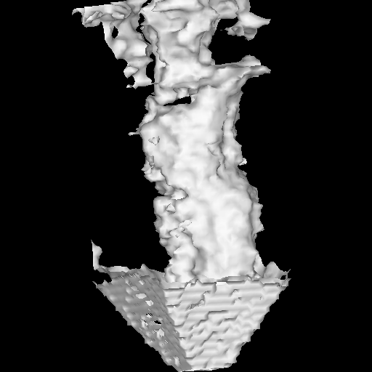
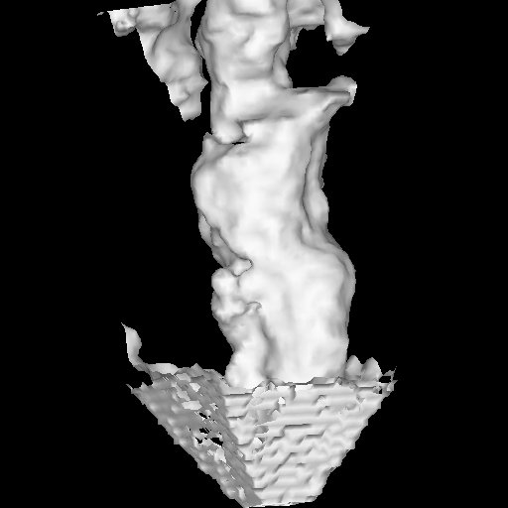
Figure 1.

